**cERTIFICATE**

**OF**

**Professional competence**

# This is to certify that

# named person

has completed the ALL MODUALS ASSOCIATED TO HUMAN

FACTORS AND ROAD RISK

.

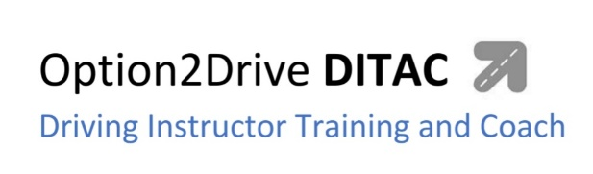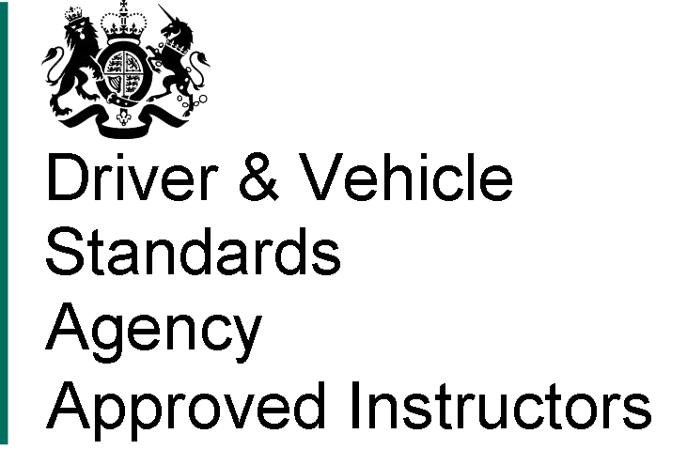

(ORDIT) Official Register of Driving Instructor Training **(Grade A)**

Authorised Signature:

**Sonny Hussein**

PRN. 368508

Date Issued:

**………………….. 2022**

**2022**

Award

